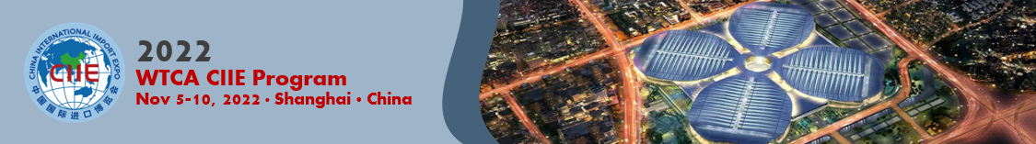
2022 WTCA CIIE PROGRAM – WTCA Member and Company Profiles for Booklet

The following information will be translated and placed in the 2022 WTCA CIIE Booklet, to be distributed in digital and hard copy format at CIIE. You are welcome to send additional marketing/promotional materials, such as a brochure, video, flyer, etc. Please note, we will be unable to ship any materials back to you, and we are unable to accept product samples for display.

WTCA Members: there is no limit to the number of member companies you submit for inclusion in the booklet. Deadline for submission is Friday, September 16.
WTCA Member Location or Company
Affiliation with which WTCA Member
Country/Region
Industry
Description of how you can serve the Chinese market (400 words max)
Images (please share up to 2 images in JPG or PNG for selection. Please paste into this table or email directly for submission)
Website
Contact Information | Full name:  Title:  Email:

- You permit the WTCA to collect and use the information that you provide for the purpose of advertising and promoting your organization. This information will be generally available to participants in the 2022 CIIE Program and their partners.
□ Yes
□ No

- You also permit the WTCA and its participating members/partners of CIIE program to use information for the sole purpose of promoting your organization and products/services beyond the 2022 CIIE Program.
□ Yes
□ No

Please submit by Friday, September 16, 2022 to:
Adele Zhang, Program Manager, WTCA Asia Pacific Regional Office (APRO)
Email: azhang@wtca.org

